
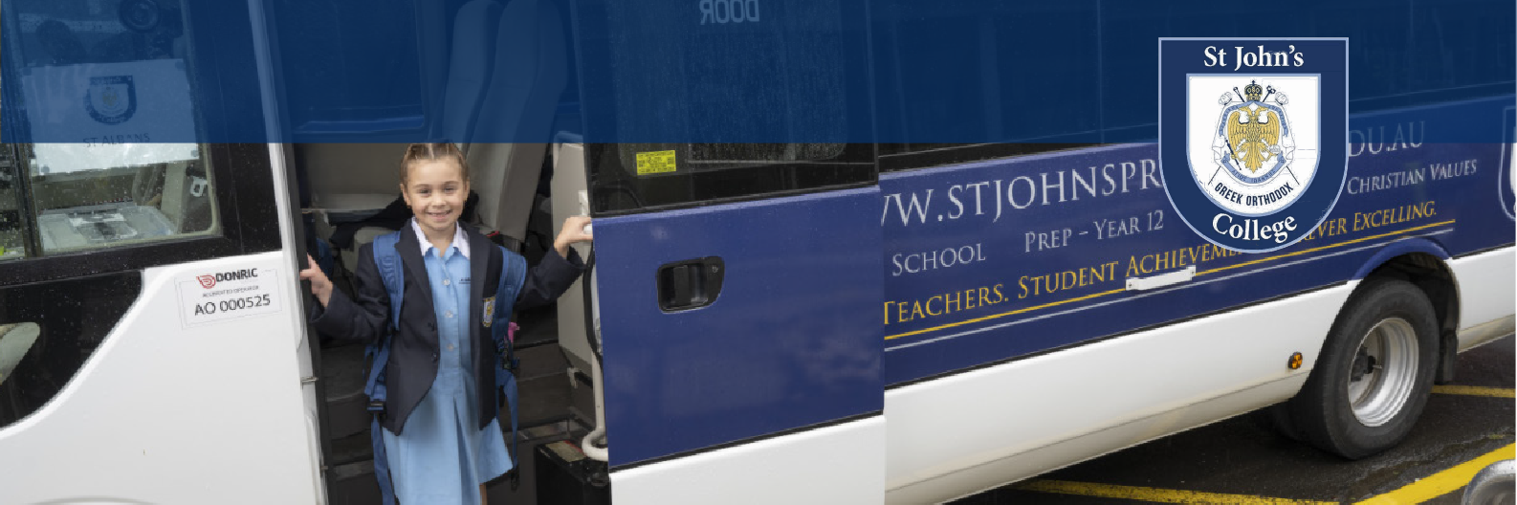
ANNUAL FEES
St John’s College offers 4 chartered bus routes for students who live in the North, West, Northwest and Eastern Suburbs of Melbourne. This service offers you the flexibility and convenience of having your child/children transported to and from the College from central bus stops, with the safety and security of a well-established bus service provider. The Private Bus Service operates all school days, Monday to Friday with the Annual Bus Fee as per the Fees Table. Parents/Guardians are required to register their child/ren annually for the bus service. All fees are invoiced annually and include GST.

$1180
Total Annual Bus Fee
(including annual admin fee) per student, per year
ST JOHN’S COLLEGE PRIVATE BUS SERVICE
BUS ROUTES
BUS 1  Greensborough - Templestowe Bus Route | Joyce Ave/Main St Bolton St/Main Rd  Greek Orthodox Parish of Doncaster & Templestowe | Greensborough Eltham Templestowe
 | Burgundy Dr/Manningham Rd | Doncaster
 | Pleasant Rd/Lonsdale St | Bulleen
 | Heidelberg Station (Layover bay closest to Yarra St) | Heidelberg
 | O'Keefe St/Bell St | Preston
 | St John's College - 1 Blanch St, Preston | Preston
BUS 2  South Morang - Epping | South Morang RS (Bay 1)  Epping Station (AM - Bay 2 | PM - Epping Station/Cooper St) | South Morang Epping
Bus Route | Greek Orthodox Church Of Thomastown | Thomastown
 | Cheddar Rd West/Keon Pde | Reservoir
 | Rosenthal Cres/Hughes Pde | Reservoir
 | Gellibrand Cres/Broadhurst Ave | Reservoir
 | Reservoir Station (AM - Spring St | PM - Edwards St) | Reservoir
 | St John's College - 1 Blanch St, Preston | Preston
BUS 3  Airport West - Glenroy Bus Route | Airport West Shopping Centre/Louis St  (AM) Mickleham Rd/Western Av/Western Av | (PM) Rylandes Dr/Mickleham Rd Ash Ct/Widford St  Joffre Rd/Boundary Rd | Airport West Westmeadows Glenroy Pascoe Vale
 | Collings Ct/Derby St | Pascoe Vale
 | Gaffney St/Derby St | Pascoe Vale
 | Batman Station  St John's College - 1 Blanch St, Preston | Preston Preston
BUS 4  St Albans West Bus Route | St Paraskevi Greek Orthodox Church (St Albans) Sage Ave/Main Rd East  Panagia Soumela Greek Orthodox Church (Keilor East) | St Albans St Albans Keilor East
 | Mary St/Hofmans Rd | Niddrie
 | (AM) - Hoddle St/Fletcher St | (PM) Nicholson St/Fletcher St | Essendon
 | Moreland Rd/ Melville Rd | Brunswick West
 | Moreland Rd/Sydney Rd | Brunswick
 | Moreland Rd/Holmes St | Brunswick East
 | St John's College - 1 Blanch St, Preston | Preston
Please note that the College reserves the right to alter the bus routes during any given school year.

